**Exercise 4: Employee Management System**

**Array Representation:**

Arrays in Java are contiguous memory blocks where elements are stored sequentially.

Advantages:

* Fast access using index (O(1) time).
* Efficient memory usage for fixed-size datasets.
* Suitable for static collections.

**Output:**

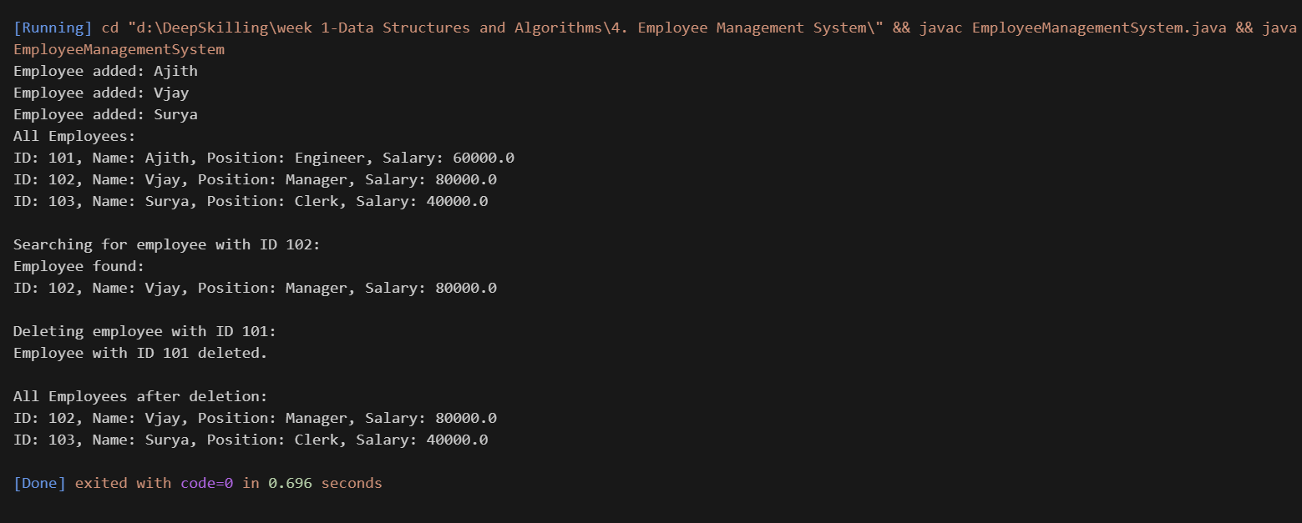

**4. Analysis:**

* **Time Complexity:**

1. Add: O(1)
2. Traverse: O(n)
3. Delete: O(n)
4. Search: O(n)

* **Limitations of Arrays:**
* Fixed size
* No built-in dynamic resizing